**Master Functional Document**

|  |  |
| --- | --- |
| **Application** | NGERP - Centra |
| **Service Bundle** | Purchase Management |
| **Service Request** | NTA Netoff Allocation |

**Description :**

NTA Netoff Allocation is used to allocate NTA AR Invoice with NTA Receipt and NTA AP Invoice with NTA Payment – AP.

**Workflow Process :**

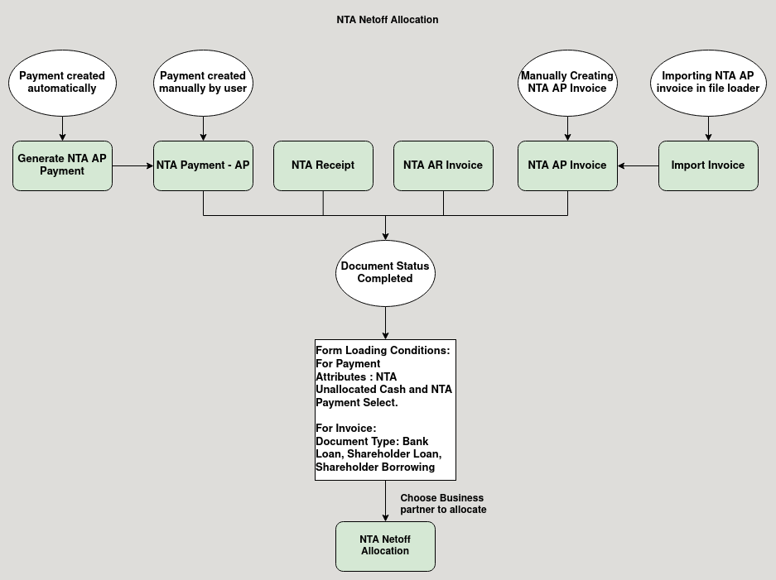

**Business Rules :**

* NTA Netoff Allocation can be only created in HQ.
* Completed Document of NTA Receipt, NTA Payment – AP, NTA AR Invoice and NTA AP Invoice will be loaded in the NTA Netoff Allocation Form.
* Form Loading Logic for Payment Tab:
  + Payment attributes should not be in NTA Unallocated Cash and NTA Payment Select.
  + Payment document type should not in Bank Loan, Shareholder Loan, Shareholder Borrowing.
  + payment should not be allocated.
  + payment document status should be in completed status.
  + Business partner shoul be active.
  + Business partner group should and group type should be non trade vendor and NTA.
  + Partner group should be in transaction group config.
* Form Loading Logic for Invoice Tab:
  + Invoice should not be paid.
  + Invoice document status should be in complted status.
  + Business partner should be active.
  + Business partner group should be active.
  + Partner group should be in transaction group config.
  + Business partner group should be in transaction group config and group type should be non trade vendor and NTA .